

Practical File Submission

Course Name: JavaScript Lab
Course Code: T-3013 / 0705210508
Submitted by
Pratyaam Sinha
24070521180
Batch: 2024-28
Semester - V
Section: C

Submitted to
Dr. Shreyas Rajendra Hole

Practical 1
Experiment Title: Demonstrate inline, internal, and external JavaScript; use console methods; create a webpage showing user info and a welcome message.
Software/Tools Required: VS Code , Web Browser
Experiment Program Code:
Demo html file:
<!DOCTYPE html>
<html>
<head>
<title>JS Demo</title>
<style>
body {
background-color: #eef3ff;
font-family: Arial, sans-serif;
text-align: center;
padding: 40px;
}

h1 {
color: #1a5cff;
}
button {
background-color: #1a5cff;

color: white;
border: none;
padding: 10px 18px;
margin: 6px;
border-radius: 6px;
font-size: 15px;
cursor: pointer;
}

button:hover {
background-color: #0d3fb0;
}

#output {
margin-top: 20px;
font-size: 16px;
color: #333;
}
</style>
</head>
<body>

<h1>Welcome to my Webpage!</h1>
<p id="output"></p>

<!-- INLINE JS -->

<button onclick="console.log('Inline JS: Button clicked!')">Inline JS</button>

<!-- INTERNAL JS -->
<button id="internalBtn">Internal JS</button>

<!-- EXTERNAL JS -->
<button id="externalBtn">External JS</button>

<script>
// INTERNAL JS - shows welcome message and logs it
document.getElementById("output").innerText = "Welcome! I am Pratyaam(24070521180) " ;
console.log("Internal JS: Page loaded, welcome message shown.");

document.getElementById("internalBtn").onclick = function () {
console.log("Internal JS: Browser - " + navigator.userAgent);
console.log("Internal JS: Platform - " + navigator.platform);
};
</script>
<script src="script.js"></script>

</body>
</html>

Output:
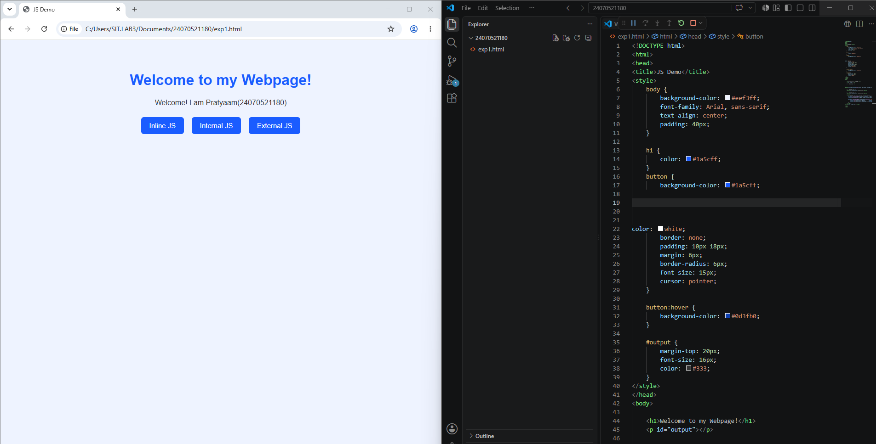

Case Study 01

Case Study Title:- Create a web page for college department and link the student information page with it and write a js program to display "Welcome to SIT Nagpur" in an alert box
Case Study Code:
Department file (HTML):-
<!DOCTYPE html>
<html>
<head>
<title>Pratyaam (24070521180) </title>
<style>
body {
background-color: #f5f8ff;
font-family: Arial, sans-serif;

margin: 0;
padding: 0;
}
header {
background-color: #1a5cff;
color: white;
padding: 20px;
text-align: center;
}
header h1 {
margin: 0;
font-size: 26px;
}
header p {
margin: 5px 0 0;
font-size: 14px;
}
.content {
max-width: 500px;
margin: 30px auto;
background-color: white;
padding: 25px;
border-radius: 8px;
border: 1px solid #ddd;
text-align: center;
}
.content h2 {
color: #1a5cff;
cursor: pointer;
}

.content p {
color: #444;
line-height: 1.6;
}
a.btn {
display: inline-block;
margin-top: 10px;
background-color: #1a5cff;
color: white;
text-decoration: none;
padding: 8px 16px;
border-radius: 5px;
font-size: 14px;
}
a.btn:hover {
background-color: #0d3fb0;
}
footer {
text-align: center;
color: #888;
font-size: 12px;
margin: 30px 0 10px;
}
</style>
</head>
<body>
<header>
<h1>SIT Nagpur</h1>
<p>Department of Computer Science</p>
</header>

<div class="content">
<!-- INLINE JS -->

<h2 onclick="console.log('Inline JS: Department title clicked!')">
Welcome to our Department Page
</h2>
<p>Click the heading above to see an inline JS console message. This page also links to the student information page below.</p>
<a class="btn" href="student-info.html">View Student Information</a>
</div>
<footer>Made by a Student &middot; SIT Nagpur</footer>
<script>
// INTERNAL JS
console.log("Internal JS: Department page loaded successfully.");
</script>
<!-- EXTERNAL JS -->
<script src="script.js"></script>
</body>
</html>
Student Info (html):-
<!DOCTYPE html>
<html>
<head>
<title>Student Information</title>
<style>
body {
background-color: #f5f8ff;
font-family: Arial, sans-serif;
margin: 0;
padding: 0;
}
header {
background-color: #1a5cff;

color: white;
padding: 20px;
text-align: center;
}
header h1 {
margin: 0;
font-size: 24px;
}
.content {
max-width: 500px;
margin: 30px auto;
background-color: white;
padding: 25px;
border-radius: 8px;
border: 1px solid #ddd;
text-align: center;
}
table {
margin: 15px auto;
border-collapse: collapse;
width: 100%;
}
td, th {
border: 1px solid #ddd;
padding: 8px 12px;
font-size: 14px;
}
th {
background-color: #eef3ff;
color: #1a5cff;

}

a.btn {
display: inline-block;
margin-top: 15px;
background-color: #1a5cff;
color: white;
text-decoration: none;
padding: 8px 16px;
border-radius: 5px;
font-size: 14px;
}
a.btn:hover {
background-color: #0d3fb0;
}
footer {
text-align: center;
color: #888;
font-size: 12px;
margin: 30px 0 10px;
}
</style>
</head>
<body>
<header>
<h1>Student Information</h1>
</header>

<div class="content">
<table>
<tr>
<th>Name</th>
<th>Roll No.</th>
<th>Branch</th>
</tr>
<tr>
<td>Your Name</td>
<td>101</td>
<td>Computer Science</td>
</tr>
</table>

<a class="btn" href="department.html">Back to Department Home</a>
</div>

<footer>Made by a Student &middot; SIT Nagpur</footer>
<script>
// INTERNAL JS
console.log("Internal JS: Student information page loaded.");
</script>
</body>
</html>

Output:

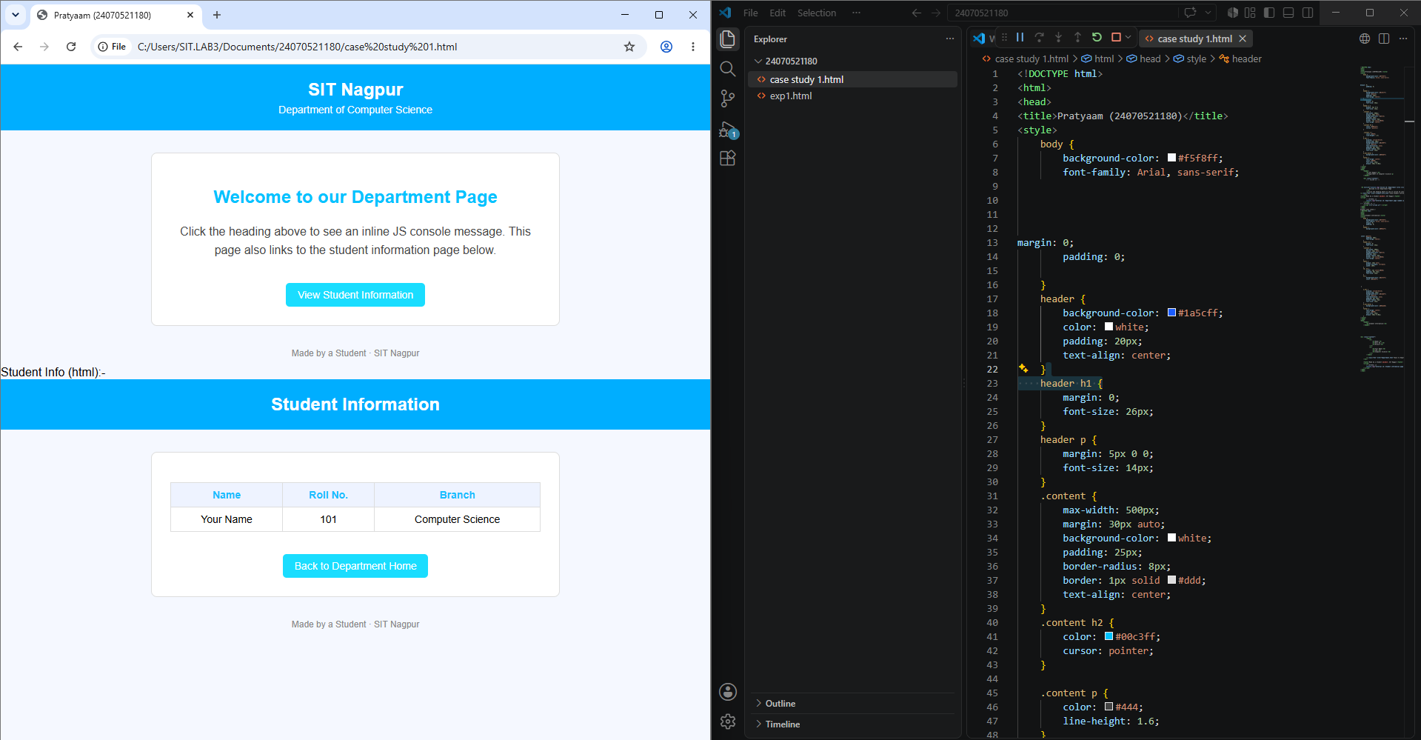

Result / Conclusion:-
Hence we have created a basic html page with javascript to show student information and and website login page.

Practical 02
Aim:- Use var, let, const, and demonstrate basic features like template literals and destructuring; build a billing calculator with user input.
Software/Tools Required: VS Code , Web Browser
Experiment program code:
Calculator.html:-
// Use var, let, const, and demonstrate basic features like template literals and destructuring; build a billing calculator with user input.
<!DOCTYPE html>
<html>
<head>
<title>Pratyaam Sinha</title>
<style>
body {
background-color: #f0f8ff; /* pastel background */
font-family: Arial, sans-serif;
margin: 0;
padding: 20px;
}
h1 {
text-align: center;
color: #1af0ff;
}
.calculator {
max-width: 600px;
margin: 30px auto;
background-color: #fff;
padding: 20px;
border-radius: 8px;
box-shadow: 0 0 10px rgba(0,0,0,0.1);
}
.item {
display: flex;
justify-content: space-between;
margin-bottom: 10px;
}
label {
width: 45%;
font-weight: bold;
}
input[type="number"] {
width: 50%;
padding: 5px;
border-radius: 4px;
border: 1px solid #ccc;
}
#total {
margin-top: 20px;
font-size: 20px;
text-align: right;
color: #333;
}
button {
display: block;
width: 100%;
padding: 10px;
background-color: #1abeff;
color: white;
border: none;
border-radius: 5px;
font-size: 16px;
cursor: pointer;
}
button:hover {
background-color: #0d8fb0;
}
</style>
</head>
<body>

Output:-
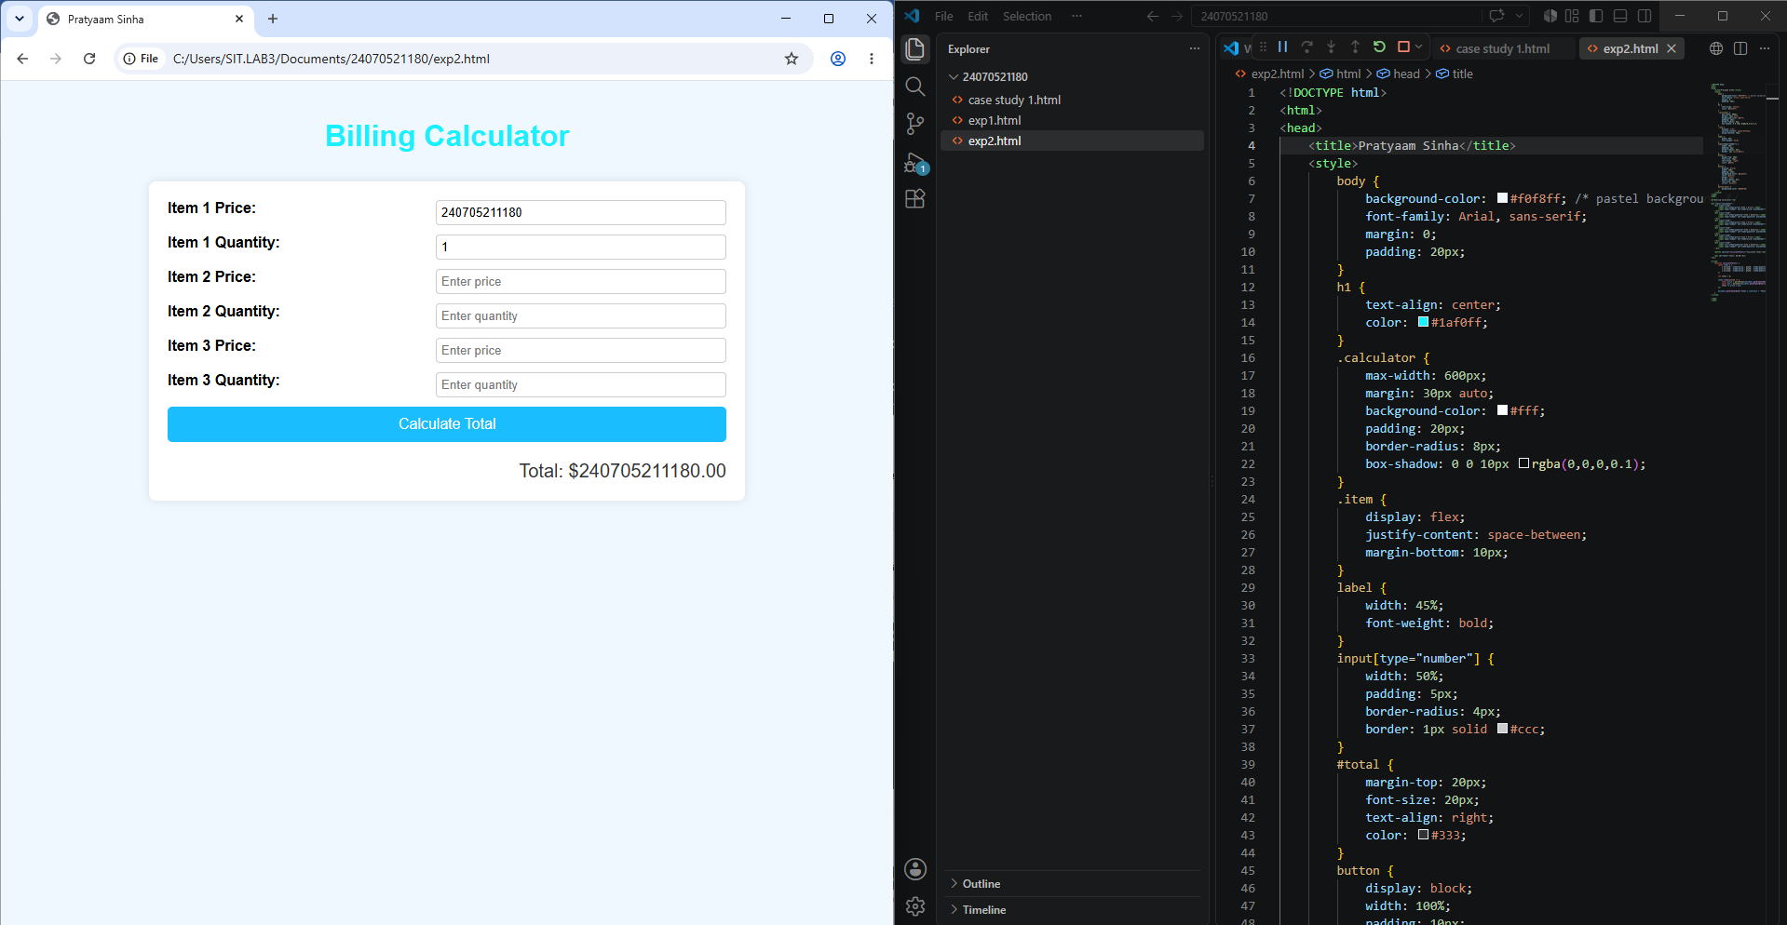

Case Study 02
Case Study Title:- Develop the webpage for an online shopping website with using HTML,CSS and HTML5 tags
Software/Tools Used:- VScode , Web Browser
Code:- <!DOCTYPE html>
<html>
<head>
<title>Billing Website</title>
<style>
body {
font-family: Arial, sans-serif;
background-color: #ffffff; /* White background */
margin: 0;
padding: 0;
display: flex;
flex-direction: column;
align-items: center;
}
h1 {
color: #ff0000; /* Red color */
margin: 20px 0;
text-align: center;
}
.container {
background-color: #fff;
padding: 20px;
border: 2px solid #ff0000; /* Red border */
border-radius: 10px;
max-width: 400px;
width: 100%;
box-shadow: 0 4px 8px rgba(0,0,0,0.1);
}
label {
display: block;
margin-top: 10px;
font-weight: bold;
}
input {
width: 100%;
padding: 8px;
margin-top: 5px;
border-radius: 5px;
border: 1px solid #ccc;
font-size: 16px;
}
button {
width: 100%;
padding: 10px;
margin-top: 15px;
background-color: #ff4d4d; /* Light red */
border: none;
border-radius: 5px;
font-size: 16px;
cursor: pointer;
color: white;
}
button:hover {
background-color: #e60000; /* Darker red on hover */
}
#bill {
margin-top: 20px;
background-color: #ffe5e5; /* Light pinkish white for bill display */
padding: 15px;
border-radius: 10px;
border: 1px solid #ff0000;
width: 100%;
}
#bill h2 {
margin-top: 0;
color: #cc0000;
}
#total {
font-weight: bold;
margin-top: 10px;
}
</style>
</head>
<body>

<h1>Pratyaam (24070521180)</h1>
<div class="container">
<label for="item">Item Name:</label>
<input type="text" id="item" placeholder="Enter item name">

<label for="price">Price (per item):</label>
<input type="number" id="price" placeholder="Enter price" min="0" step="0.01">

<label for="quantity">Quantity:</label>
<input type="number" id="quantity" placeholder="Enter quantity" min="1" step="1">

<button onclick="generateBill()">Generate Bill</button>

<div id="bill" style="display:none;">
<h2>Bill Details</h2>
<div id="billDetails"></div>
<div id="total"></div>
</div>
</div>

<script>
function generateBill() {
const itemName = document.getElementById('item').value.trim();
const price = parseFloat(document.getElementById('price').value);
const quantity = parseInt(document.getElementById('quantity').value);

if (itemName === "" || isNaN(price) || isNaN(quantity) || price < 0 || quantity < 1) {
alert("Please enter valid item details.");
return;
}

const gstRate = 0.18; // 18% GST
const amount = price * quantity;
const gstAmount = amount * gstRate;
const totalAmount = amount + gstAmount;

const billDetailsDiv = document.getElementById('billDetails');
billDetailsDiv.innerHTML = `
<p><strong>Item:</strong> ${itemName}</p>
<p><strong>Price per item:</strong> ₹${price.toFixed(2)}</p>
<p><strong>Quantity:</strong> ${quantity}</p>
<p><strong>Subtotal:</strong> ₹${amount.toFixed(2)}</p>
<p><strong>GST (18%):</strong> ₹${gstAmount.toFixed(2)}</p>
`;

document.getElementById('total').innerText = `Total Amount (including GST): ₹${totalAmount.toFixed(2)}`;

document.getElementById('bill').style.display = 'block';
}
0000000000000000000

</body>
</html>

Output:-
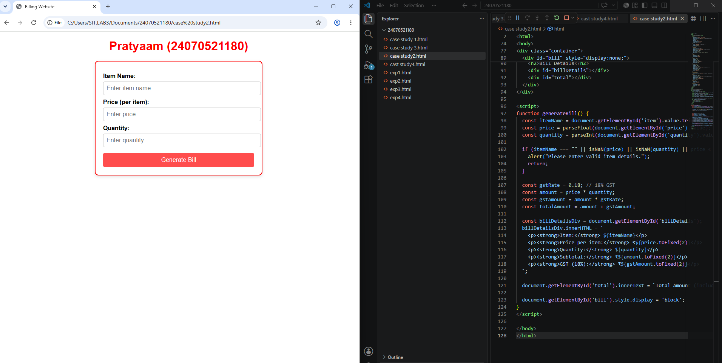

Practical 3
Aim:- Implement control structures and form validation; create a grading system based on user-entered marks.
Software/Tools Required: VS Code , Web Browser
Experiment program code:
Student Marks and grade:-
<!DOCTYPE html>
<html>
<head>
<title>Pratyaam Sinha (24070521180)</title>
<style>
body {
background-color: #e0f7fa; /* pastel cyan/light blue */
font-family: Arial, sans-serif;
margin: 0;
padding: 20px;
}
h1 {
text-align: center;
color: #1a5cff;
}
.checker {
max-width: 500px;
margin: 30px auto;
background-color: #fff;
padding: 20px;
border-radius: 8px;
box-shadow: 0 0 10px rgba(0,0,0,0.1);
}
label {
display: block;
margin-bottom: 8px;
font-weight: bold;
}
select {
width: 100%;
padding: 8px;
margin-bottom: 15px;
border-radius: 4px;
border: 1px solid #ccc;
}
button {
width: 100%;
padding: 10px;
background-color: #1a5cff;
color: white;
border: none;
border-radius: 5px;
font-size: 16px;
cursor: pointer;
}
button:hover {
background-color: #0d3fb0;
}
#result {
margin-top: 20px;
font-size: 18px;
text-align: center;
font-weight: bold;
}
</style>
</head>
<body>

<h1>Student Scholarship Checker</h1>

<div class="checker">
<form id="gradeForm">
<label for="grade1">Subject 1 Grade:</label>
<select id="grade1" required>
<option value="">Select Grade</option>
<option value="A">A</option>
<option value="B">B</option>
<option value="C">C</option>
<option value="D">D</option>
<option value="F">F</option>
</select>

<label for="grade2">Subject 2 Grade:</label>
<select id="grade2" required>
<option value="">Select Grade</option>
<option value="A">A</option>
<option value="B">B</option>
<option value="C">C</option>
<option value="D">D</option>
<option value="F">F</option>
</select>

<label for="grade3">Subject 3 Grade:</label>
<select id="grade3" required>
<option value="">Select Grade</option>
<option value="A">A</option>
<option value="B">B</option>
<option value="C">C</option>
<option value="D">D</option>
<option value="F">F</option>
</select>

<button type="button" onclick="checkScholarship()">Check Scholarship Eligibility</button>
</form>
<div id="result"></div>
</div>

<script>
function checkScholarship() {
const grades = [
document.getElementById('grade1').value,
document.getElementById('grade2').value,
document.getElementById('grade3').value
];

// Convert grades to scores
const gradePoints = {
'A': 4,
'B': 3,
'C': 2,
'D': 1,
'F': 0
};

let totalPoints = 0;
let subjectCount = grades.length;
let eligible = true;

for (let grade of grades) {
if (grade === "") {
alert("Please select all grades.");
return;
}
totalPoints += gradePoints[grade];
if (grade === 'F') {
eligible = false;
}
}

const average = totalPoints / subjectCount;

// Define criteria for scholarship
if (average >= 3.5 && eligible) {
document.getElementById('result').innerText = "Congratulations! You are eligible for the scholarship.";
document.getElementById('result').style.color = "green";
} else {
document.getElementById('result').innerText = "Sorry, you are not eligible for the scholarship.";
document.getElementById('result').style.color = "red";
}
}
</script>

</body>
</html>

Output:-
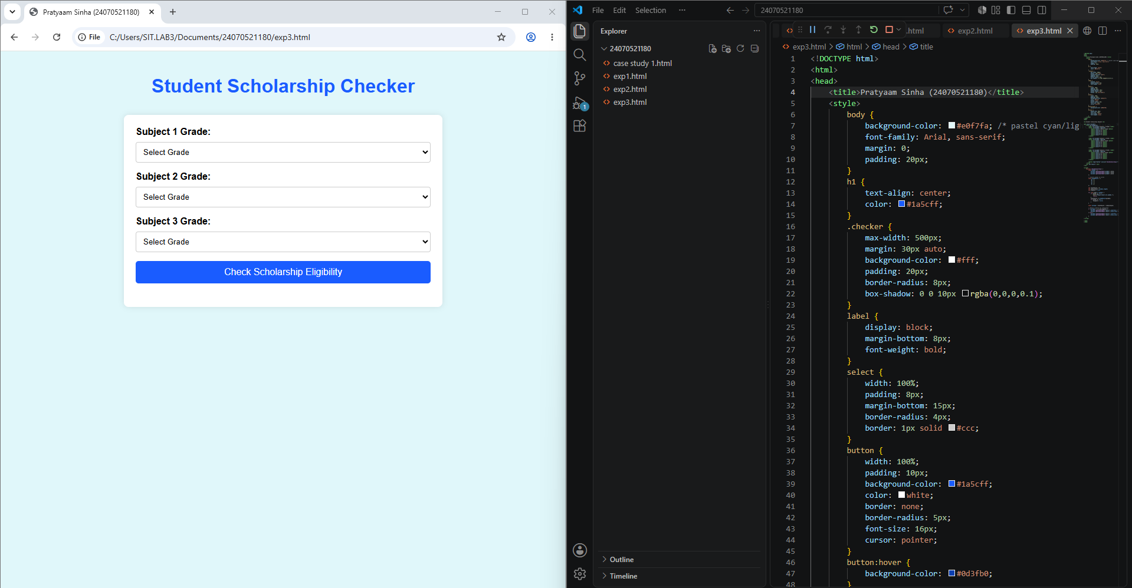

Case Study 03
Case Study Title:- Scholarship Eligibilty:
A college awards scholarship based on marks
Below 50:- Not eligible
50-69:- Bronze Scholarship
70-84:- Silver Scholarship
85-94:- Gold Scholarship
95-100:- Platinum Scholarship
Software/Tools Used:- VScode , Web Browser
Case Study Code:-
!DOCTYPE html>
<html>
<head>
<title>Scholarship Checker</title>
<style>
body { font-family: Arial; background: #f0f0f0; padding: 20px; }
input, button { padding: 8px; margin-top: 10px; width: 200px; }
#result { margin-top: 20px; font-weight: bold; }
</style>
</head>
<body>
<h2>Pratyaam Sinha (24070521180)</h2>
<input type="number" id="marks" placeholder="Enter marks (0-100)" min="0" max="100">
<button onclick="checkScholarship()">Check</button>
<div id="result"></div>
<script>
function checkScholarship() {
const m = parseInt(document.getElementById('marks').value);
let msg = "";
if (isNaN(m)) { msg = "Please enter valid marks."; }
else if (m < 50) { msg = "Not eligible"; }
else if (m <= 69) { msg = "Bronze Scholarship"; }
else if (m <= 84) { msg = "Silver Scholarship"; }
else if (m <= 94) { msg = "Gold Scholarship"; }
else { msg = "Platinum Scholarship"; }
document.getElementById('result').innerText = msg;
}
</script>
</body>
</html>

Output:-
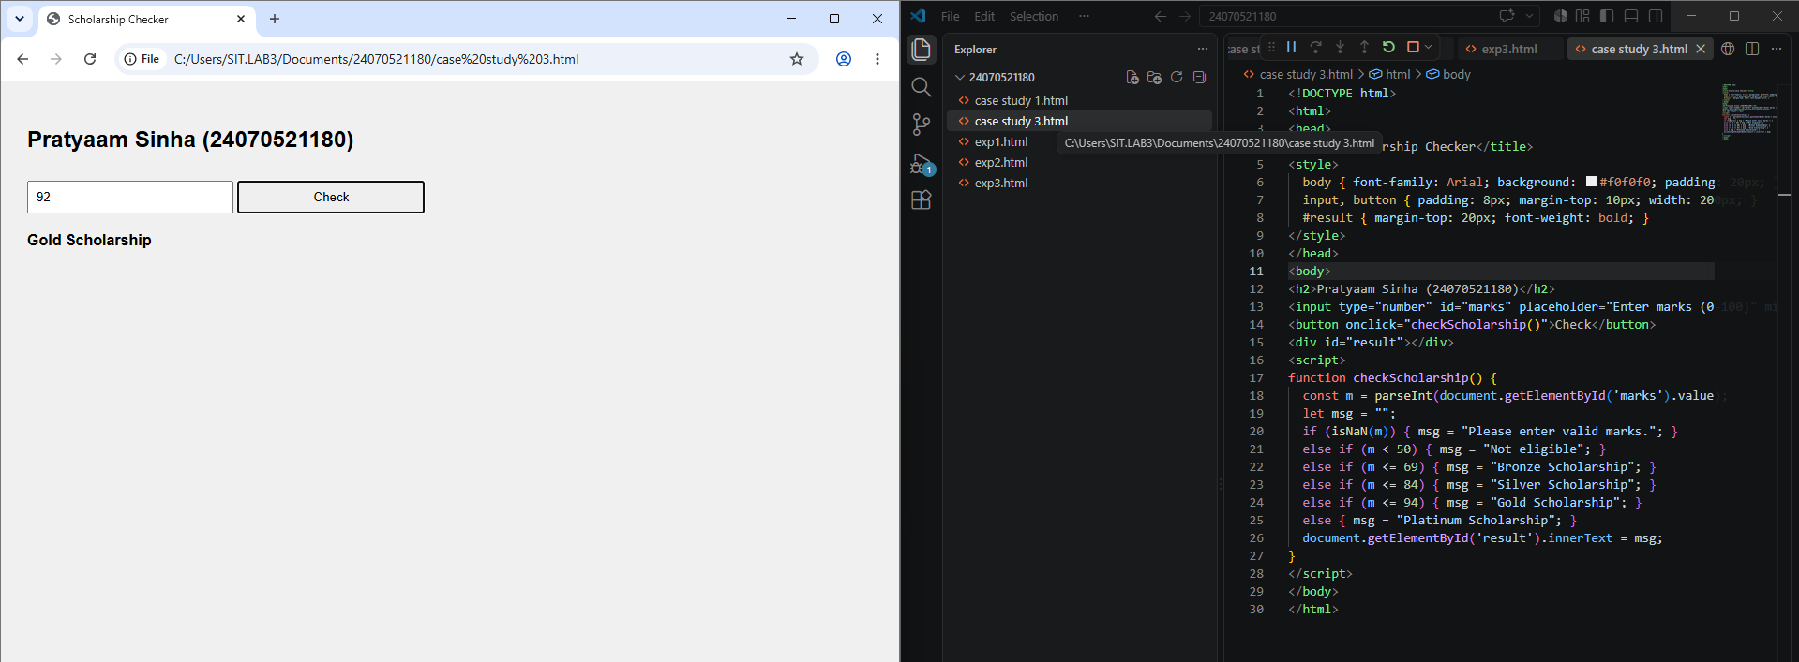

Practical 4
Aim:- Use function types ,scope , and closure; apply try catch ;build a palindrome checker
Software/Tools Required: VS Code , Web Browser
Experiment program code:
Palindrome checker:-
<!DOCTYPE html>
<html>
<head>
<title>Palindrome Checker</title>
<style>
body {
font-family: Arial, sans-serif;
background-color: #f9e2ff; /* Pastel purple */
display: flex;
flex-direction: column;
align-items: center;
justify-content: center;
min-height: 100vh;
margin: 0;
}
h1 {
color: #ff69b4; /* Pastel pink */
text-align: center;
}
.container {
background-color: #fff0f5; /* Pastel pinkish white */
padding: 20px;
border-radius: 10px;
box-shadow: 0 4px 8px rgba(0,0,0,0.1);
max-width: 300px;
width: 100%;
}
input {
width: 100%;
padding: 8px;
margin-top: 10px;
border-radius: 5px;
border: 1px solid #ccc;
font-size: 16px;
}
button {
width: 100%;
padding: 10px;
margin-top: 15px;
background-color: #87cefa; /* Pastel blue */
border: none;
border-radius: 5px;
font-size: 16px;
cursor: pointer;
}
button:hover {
background-color: #00bfff; /* Bright blue on hover */
}
#result {
margin-top: 20px;
font-weight: bold;
font-size: 18px;
text-align: center;
}
</style>
</head>
<body>

<h1>PRATYAAM (24070521180)</h1>
<div class="container">
<input type="text" id="inputString" placeholder="Enter text">
<button onclick="checkPalindrome()">Check Palindrome</button>
<div id="result"></div>
</div>

<script>
function checkPalindrome() {
const str = document.getElementById('inputString').value.trim().toLowerCase();
const reversed = str.split('').reverse().join('');
const resultDiv = document.getElementById('result');

if (str === "") {
resultDiv.innerText = "Please enter some text.";
return;
}

if (str === reversed) {
resultDiv.innerText = `"${str}" is a Palindrome!`;
resultDiv.style.color = "green";
} else {
resultDiv.innerText = `"${str}" is not a Palindrome.`;
resultDiv.style.color = "red";
}
}
</script>

</body>
</html>
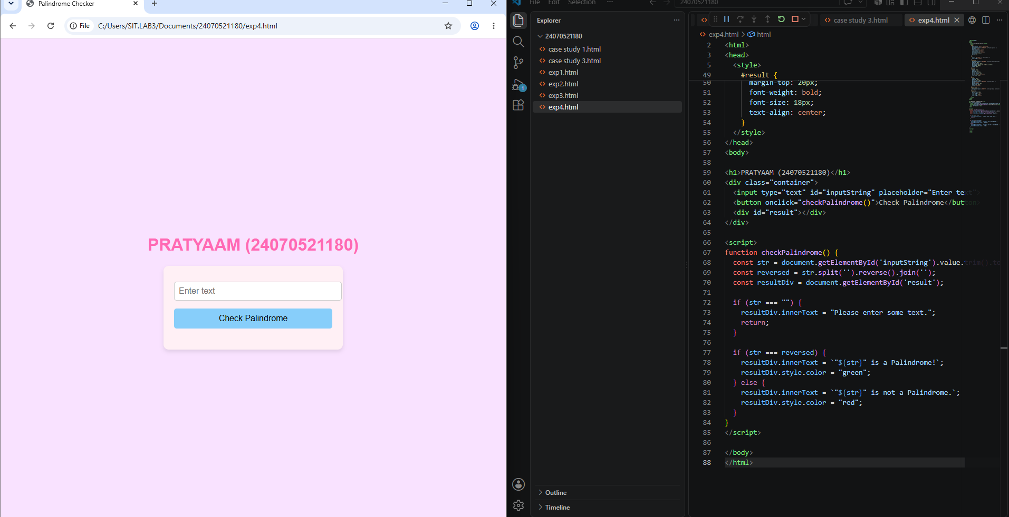
Output:-

Case Study 04
Real-Time Case Study: ATM Card PIN Verification Using JavaScript Functions
Case Study An ATM system verifies whether a customer's PIN is a palindrome. If the PIN reads the same forward and backward, the bank displays a special security message. To implement this, create a function to reverse the entered PIN number and another function to check whether it is a palindrome. Use function declaration, function expression, arrow function, and demonstrate scope concepts
Software/Tools Used:- VScode , Web Browser
Case Study Code:-
<!DOCTYPE html>
<html>
<head>
<title>ATM PIN Palindrome Check</title>
<style>
body {
font-family: Arial, sans-serif;
background-color: #e0f7fa; /* Pastel cyan */
display: flex;
flex-direction: column;
align-items: center;
justify-content: center;
min-height: 100vh;
margin: 0;
}
h1 {
color: #00796b; /* Pastel teal */
text-align: center;
}
.container {
background-color: #ffe0b2; /* Pastel orange */
padding: 20px;
border-radius: 10px;
box-shadow: 0 4px 8px rgba(0,0,0,0.1);
max-width: 300px;
width: 100%;
}
input {
width: 100%;
padding: 8px;
margin-top: 10px;
border-radius: 5px;
border: 1px solid #ccc;
font-size: 16px;
}
button {
width: 100%;
padding: 10px;
margin-top: 15px;
background-color: #aed581; /* Pastel green */
border: none;
border-radius: 5px;
font-size: 16px;
cursor: pointer;
}
button:hover {
background-color: #9ccc65; /* Slightly darker green on hover */
}
#message {
margin-top: 20px;
font-weight: bold;
font-size: 18px;
text-align: center;
}
</style>
</head>
<body>

<h1>Pratyaam (24070521180)</h1>
<div class="container">
<label for="pin">Enter PIN:</label>
<input type="text" id="pin" maxlength="10" placeholder="Enter your PIN">
<button onclick="checkPIN()">Verify PIN</button>
<div id="message"></div>
</div>

<script>
function checkPIN() {
const pin = document.getElementById('pin').value.trim();
const messageDiv = document.getElementById('message');

if (pin === "") {
messageDiv.innerText = "Please enter your PIN.";
messageDiv.style.color = "black";
return;
}

const reversedPin = pin.split('').reverse().join('');
if (pin === reversedPin) {
messageDiv.innerText = "Security Alert: Your PIN is a palindrome! Be cautious.";
messageDiv.style.color = "green";
} else {
messageDiv.innerText = "Your PIN is not a palindrome.";
messageDiv.style.color = "blue";
}
}
</script>

</body>
</html>

Output:-

